| **Test Name** | | Unsuccessful login | | | |
| --- | --- | --- | --- | --- | --- |
| **Use Case Tested:** | | Use Case 13 – Log in | | | |
| **Test Description:** | | User wishes to enter an error.  User enters a username.  User enters a password.  The username and/or password are incorrect and they do not relate to each other  User selects Submit button.  User is presented with a login error. | | | |
| **Pre-conditions** | | A valid user name and password exists for user | | | |
| **Post-conditions** | | Login error is presented | | | |
| **Notes:** | | *Screenshots relating to test can be found after the Test Data Table*  *Need to decide about the error message remaining on screen after clear button clicked* | | | |
| **Result (Pass/Fail/Warning/Incomplete)** | |  | | | |
|  | **TEST STEP** | | **EXPECTED TEST RESULTS** | P | F |
|  | User enters an email | | No error appears | P |  |
|  | User enters a password | | No error appears | P |  |
|  | User selects Submit button | | Login error appears and user is required to enter a valid username and password | P |  |
|  | User bypasses the email field | | Error stating field is required | P |  |
|  | User bypasses the password field | | Error stating field is required | P |  |
|  | Fields empty and Login selected | | Login error appears and user is required to enter a valid username and password | P |  |

|  |  |  |  |  |  |
| --- | --- | --- | --- | --- | --- |
| **Test Data Table** | | | | | |
|  | **1** | **2** | **3** | **4** | **5** |
| Invalid Email: | test@test.cim |  |  |  |  |
| Valid Password: | 12345678 |  |  |  |  |
|  |  |  |  |  |  |
| Valid Email: | frank@test.com |  |  |  |  |
| Invalid Password: | 87624321 |  |  |  |  |
|  |  |  |  |  |  |
| Invalid Email: | juels@test.com |  |  |  |  |
| invalid Password: | paasword |  |  |  |  |
|  |  |  |  |  |  |
| Invalid Email: | admin@test.com.au |  |  |  |  |
| invalid Password: | Super123 |  |  |  |  |
|  |  |  |  |  |  |
| Email: | Blank |  |  |  |  |
| Password: | Blank |  |  |  |  |

SCREENSHOTS RELATING TO TEST

Test 1

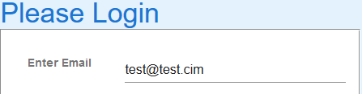

Invalid username entered

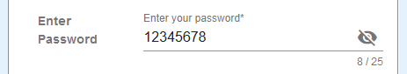 (Note previous tests, showing password option not selected)

Valid password entered – Login button clicked

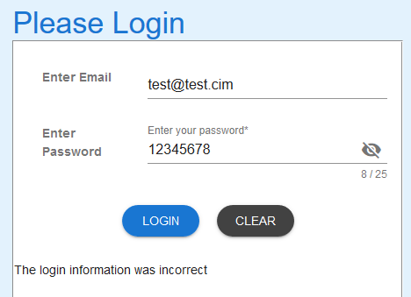

Error message appears



Server command window shows execution of sql script but no results returned.

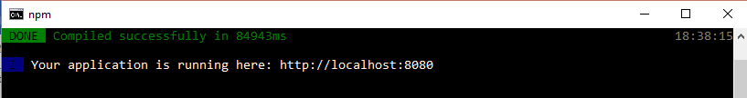

Client command window – no errors

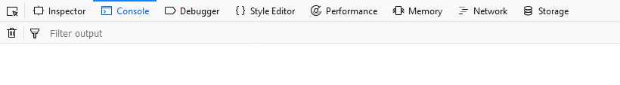

No log on the browser.

Selecting Clear cleared the Username & Password fields. However, the error message did not clear.

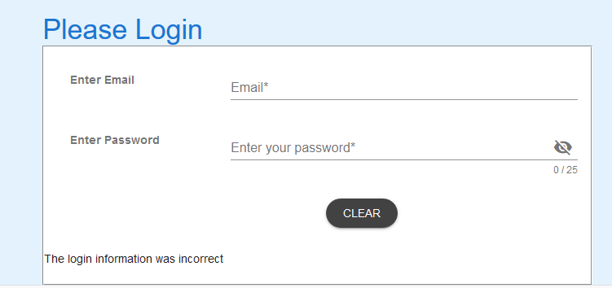

Test 2 – Valid username and invalid password

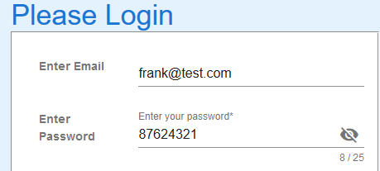

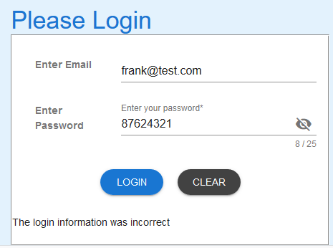

Error message appears and user is not logged in.

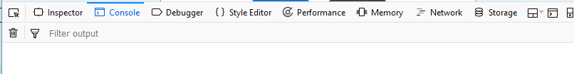

Browser log shows no entries



Server command window indicates query launched on username but as the password is invalid, no further activity occurs.

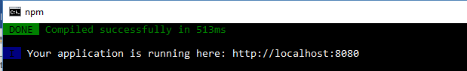

No action occurring on the Client command window.

Test 3

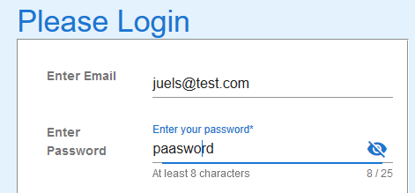

Invalid email and password entered, Login selected

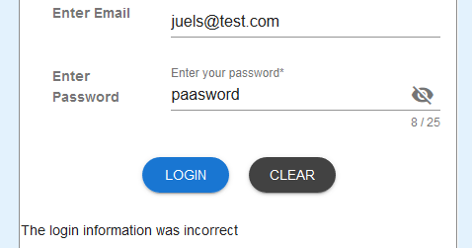

Error message appears.



Console on Browser is blank



Server command window shows query with no results flowing through.



No action occurring on the Client command window.

Test 4

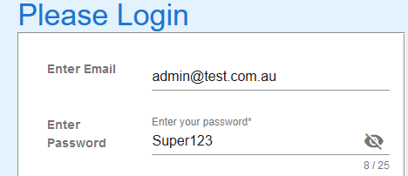

Invalid email and password entered, Login selected

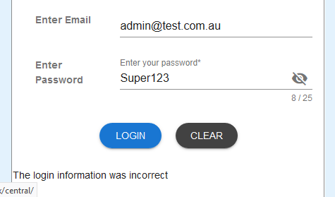

Error message appears.



Console on Browser is blank



Server command window shows query with no results flowing through.



No action occurring on the Client command window.

Test 5

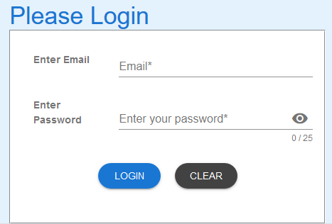

Login page prior to bypassing fields.

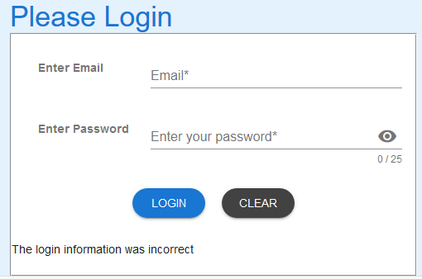

Selecting LOGIN without clicking in fields causes error message to occur.



Console on Browser is blank



Server command window shows query with no results flowing through.



No action occurring on the Client command window.

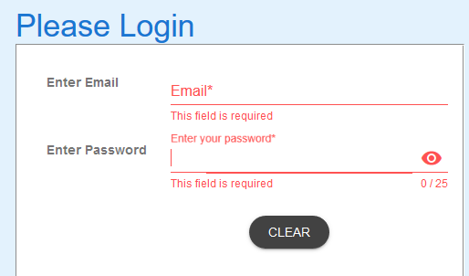

Clicking in fields and bypassing them causes LOGIN button to disappear and error messages to occur.

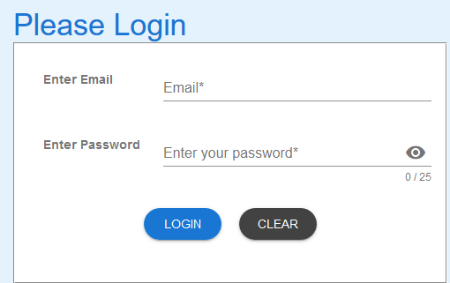

Selecting CLEAR resets the login page.



No further action occurs on the Server command window.



Console on Browser is blank



No action occurring on the Client command window.